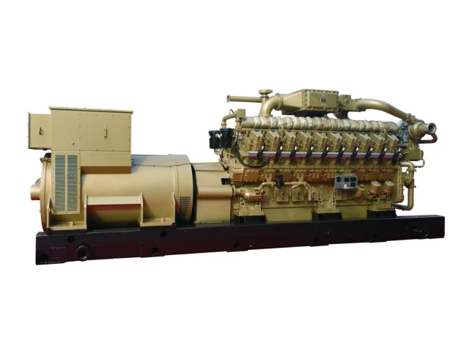**CNPCJPEC 2000GF-T NATURAL GAS GEN-SET 2000kW**

**ENGINE SPECIFICATIONS**

**V-16, 4-Stroke-Cycle-Engine (190 series)**

Bore---------------------------------------------------190mm

Stroke-------------------------------------------------255mm

Displacement----------------------------------------144.6L

Aspiration-------------------Turbocharged-After cooled

Speed Control-------------Electronic Speed governing

Rated Speed------------------------------ ------ -1000rpm

Rated power-----------------------------------------2000kW

**INTRODUCTION**

L20V190ZLT-2 outer mixing gas engine is developed by our company to meet the requirement of market. The whole engine is optimized by amending the shortages of the first gas engine generation. The power performance, fuel economy and reliability of this gas engine are improved a lot by adopting outer mixing mode, increasing compression ratio and boost ratio, enhancing swirl ratio, realizing lean-burnt by controlling air fuel ratio, using high-energy ignition, and etc.

This engine series is mainly used in generating by single engine or several engines forming a power station. It also can be used as power of compressor, oil transfer pump, water injection pump, and etc.

**MAIN FEATURES**

|  |  |
| --- | --- |
| **Engine Design**  - Designed by AVL, Austria  - Intellectual Property belong to JCPC  - Triaxiality Finite Element Analysis  - Longer Stroke, More displacement  - Low Speed (1000RPM), More Reliable  - Advanced World Standard Performance  **Generator**  **-** Brushless Excitation  -AVR  - Better Insulation and Protection  **Safety**  - Low Oil Pressure Auto Stop Protection  - Over Speed Auto Stop Protection  - Explosion Proof  - High Coolant Temperature Alarm  - Low Coolant Level Alarm  - High Oil Temperature Alarm  - Complete Electrical Protection  - Emergency Stop Device | **Testing**  - Strict Inspection and Factory Test for Each Gen-set  - Start Performance Test  - Load Test  - Synchronization Test  - Safety System Test  **The Whole Equipment Supply**  - Standard Scope of Supply  - Repairing Tools  **Easy Installation and Remove**  - All Equipment on Common Skid Three-Point Support  -Simple Installation Work  - High Strength Skid, for Hoisting and Removing.  **Technical Support & Services**  - Technical Support and Training Service  - 24/7 Technical Service Tel Number  - Rapid Spare Parts Supply  - After Sales Service for Generator Set Lifetime |

**Property Parameter Table**

|  |  |
| --- | --- |
| Model | 2000GF-T |
| Engine type | L20V190ZLT-2 |
| Alternator type | 1FC series（siemens technology） |
| Rated Power * kW | 2000 |
| Rated Speed rpm | 1000 |
| Rated Frequency Hz | 50 |
| Electrical Efficiency | ≥40% |
| Rated PF | 0.8 |
| Voltage Regulation | AVR |
| Turbocharger Brand | ABB |
| Alternator Brand | Domestic Factory（siemens technology） |
| Ignition System Brand | Motortech |
| Control System Brand | Woodward |
| Weight kg | 30000 |
| Dimension mm | 7150×2040×2786 |

*Rating and fuel consumption based on ISO Standard conditions (Ambient temperature at 25 degree Centigrade, Atmospheric pressure at 100kPa and Relative humidity at 30%). Site rating and fuel consumption should amend according to relative standard (The table at right side for reference )

**Main Specification of Engine**

|  |  |
| --- | --- |
| Model of engine | L20V190ZLT-2 |
| Rated Power(kW) | 2000kW |
| Rated Speed(r/min) | 1000 |
| No. and layout of cylinders | 20-cylinder，60°Vee |
| Type | Four stroke, Water cooled, Direct injection, Air-fuel ratio control, Spark plug ignition, Out mixing,  Electrical control, Mixed after compressor, Turbocharged and after cooled. |
| Heat consumption | ≤8700kJ/kW·h |
| Specific oil consumption (g/kW.h) | ≤0.6 |
| Bore(mm) | 190 |
| Stroke (mm) | 255 |
| Total displacement (L) | 144.6 |
| Governor | Electronic Governor |
| Exhaust temperature （before turbo） | ≤640℃ |
| Starting mode | 24V DC electric starting motor |
| Direction of rotation | Counter-clockwise(facing to flywheel) |
| Lubrication method | Pressure and splash lubrication |
| Hot water outlet temperature | <90℃ |
| Mid-cooler inlet water temperature | <45℃ |
| Oil temperature | <90℃ |
| Stable regulating rate | 0～5 % adjustable |
| Cooling method | Horizontal radiator |
| Manufacturer | CNPC Jichai Power Co., Ltd |

**Main Specification of Alternator**

|  |  |
| --- | --- |
| Model of alternator | 1FC series（siemens technology） |
| Rated power(kW) | 2000 |
| Rated voltage(V) | 400 |
| Coupling | Elastic |
| Voltage regulator | 3 phase sensing with volts/Hz. |
| Voltage regulation | Less than +/-0.5% in steady state and less than +/- 0.5% with 3% speed change. |
| Rated frequency | 50Hz |
| Power factor | COS￠=0.8 |
| Wiring mode | Three-phase four-wire system（Y） |
| Excitation mode | Brushless excitation |
| Insulation class | F |
| Running mode | Continuous |
| Protective class | IP23 |
| Rotating direction | Anticlockwise(Facing to input end) |

**STANDARD SCOPE OF SUPPLY**

|  |  |
| --- | --- |
| **Natural Gas Engine**  **Air inlet system**  Air Filter  Air Cooler  Bracket  **Control system**  Governor  Control Panel  Explosion Proof  Safety Protection System  **Exhaust system**  Exhaust Gas Turbocharger  Exhaust Manifold  Corrugated Pipe  Exhaust Pipe  Exhaust Elbow  Exhaust Silencer  **Cooling system**  Horizontal Radiator | **Starting System**  DC Starting Motor  Electric Starter 24 Volt  **Lubricating System**  Main Oil Pump  Lube Oil Filter  Lube Oil Cooler  Lube Oil Centrifugal Filter  **Alternator**  Brushless Excitation Alternator  AVR(Digital Mode)  **Spares**  Normal Repair Tools  Special Spare Parts  Technical Document  **Others**  Common Skid  Elastic Coupling |

**Delivery date**

Three months after contract valid or negotiation by both parties.

**Warranty**

One year after delivery or accumulative 1500 hours running time, according to which one comes first.

**Installation and commissioning**

If customer needs our company to do the guiding installation and commissioning, our company will arrange two engineers to do the field service. All the fees including the traffic, living condition and insurance in abroad will be provided by the customer.